What is a function – basics?
Function $f$ is a relation in which _______________ from the set of inputs $X$ is associated to ___________________ from the set of outputs $Y$. Each function must have three elements defined:
1. Domain $X$ – a set of inputs, i. e. a set of all arguments of the function
2. Mapping rule $f$ – the way this data is transformed - functional equation
3. Codomain $Y$ – a set of possible outputs

Video 01
Functions are: ______________________________

Example 3
$f:R→R$
$$f(x)=x^{2}-1$$
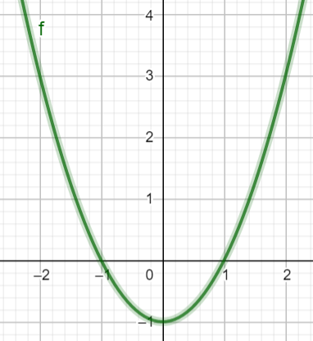

$$g:〈0,∞〉→〈-1,∞〉$$
$g(x)=x^{2}-1$
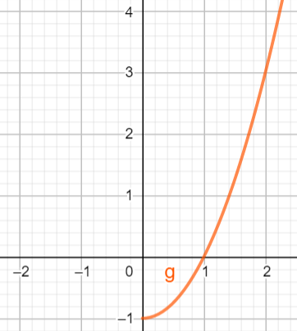

Example 1b
More then 20 000 students enroled in college in Croatia in 2021. Is the mapping in which each student who enroled in exactly one college is asociated with a college:
- function
- injection
- surjection
- bijection

Example 4
Each point on the Earth's surface is associated with a unique combination of two coordinates. On Google maps choose the place you want to travel to next summer and read its longitude and latitude.
Convert the values in degrees to degrees, minutes, and seconds.

Longitude _____________________________

Latitude _______________________________

Is the mapping that accompanies each point on the Earth's surface an ordered pair of number coordinates:
- function
- injection
- surjection
- bijection

Example 5
In a port 300 passengers can board one of the 3 ships (A, B or C) that depart at the same time. Each ship has at least 2 passengers.
Is the mapping in which each passenger is associated to a ship:

- function
- injection
- surjection
- bijection

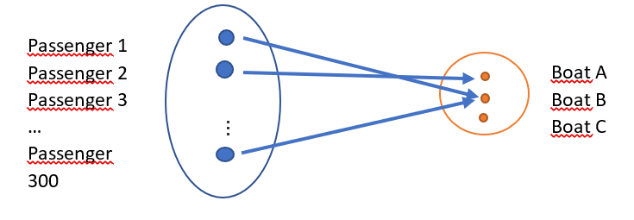

Example 6
The GPS system receives messages about the coordinates of the Nautilus ship every hour during the four-hour voyage.
The last voyage of a ship is given by the table:

Time | X coordinate (Northern latitude) | Y coordinate  (Eastern longitude)
12:00 | 44.52 | 14.51
13:00 | 44.52 | 14.62
14:00 | 44.52 | 14.69
15:00 | 44.52 | 14.81
16:00 | 44.52 | 14.89

https://www.geogebra.org/m/shtqu5kq
a) In which direction did the ship move? What was its course?

From __________________________ to ___________________
b) If we know that the total length of the voyage was 24 km, what was the average speed of the ship?

____________________________________________________
c) Did the ship have a steady speed during the voyage? __________
d) When did the ship go the fastest and when the slowest?
The fastest interval __________________
The slowest interval _________________

e) Determine the speed of the ship in each of the intervals.
Time | ∆Y coordinate (longitude) | ∆Y coordinate (km) | v (km/h)
12:00 – 13:00
13:00 – 14:00
14:00 – 15:00
15:00 – 16:00

f) Try to determine the $Y$ coordinate of the ship in each time interval if the ship moved at a constant velocity of 6 km/h.
Time | Y coordinate (Eastern longitude) (real values) | Y coordinate (Eastern longitude) (with constant velocity 6/km/h)
12:00 | 14.51 | 14.51
13:00
14:00
15:00
16:00 | 14.89 | 14.89

g) If 1 knot = 1.85 km/h, what was the average velocity of the ship in knots
______________________________

Example 7 – hydrostatic pressure
https://phet.colorado.edu/sims/html/under-pressure/latest/under-pressure_en.html
a) When the depth increases, the pressure __________.
b) What is the atmospheric pressure (the pressure at 0 m, in pool level)?
___________

c) Fill out the table and sketch the graph:

Water depth (m) | Water pressure (kPa)
0
1
2
3

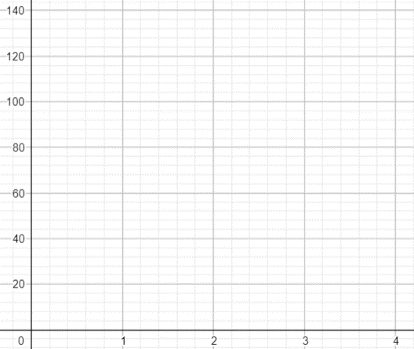

d) What can you notice about the points? Is there a pattern?
___________________

e) The hydrostatic pressure formula is:
$$p_{hyd}\left(h\right)=__________________$$

$$p_{hyd}\left(h\right)=__________________$$
f) Given the saltwater density is $ρ=1 025 kg/m^{3},$ the atmospheric pressure is $p_{atm}=101 325 Pa$ and $g=9.81m/s^{2}$, determine the hydrostatic pressure at a depth of 40 m?

g) The world record in deep sea diving (without injury) is _____ m. With conditions described above ($ρ=1025\frac{kg}{m^{3}}, p_{atm}=101 325 Pa$,$g=9.81m/s^{2}$) determine the pressure at the given depth.
h) What is the percent increase in water pressure at depth _____ m when compared with atmospheric pressure?

