Trigonometry

What is a radian angle?

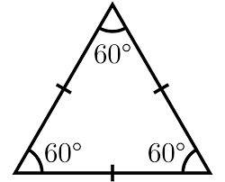
If we bend one side what will happen to the measure of the opposite angle?
a) decrease
b) stay the same
c) increase

Exercise 1
Convert the angles:
a) $\frac{5π}{6}=$ b) $20\text{°}\text{=}$ c) $2 rad ≈$

How to read a radar?

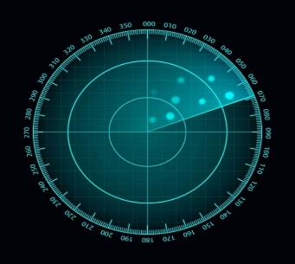
direction | azimuth
N
E
W
S

Exercise 2
A submarine accompanies a ship on its voyage.
At each point in time, the ships distance is 200 meters in the direction 060.
The submarine captain spots a dangerous reef located directly north from the submarines’ location, 200 m away.
1) Plot the point locating the reef in Geogebra.
2) What is the distance from the ship to the reef? _____________
3) What would be the reefs azimut when observed from the ship? ____________

The ships safe harbour is located 400 m away, in the direction 300 from the current submarine location.
- Plot the harbour location
- Determine the distance from the ship to the harbour
Sine law $\frac{a}{sinα}=\frac{b}{sinβ}=\frac{c}{sinγ}$
Cosine law $a^{2}=b^{2}+c^{2}-2bc\cos{α}$

- Determine the course (azimuth) of the ship if it wants to reach the harbour

Exercise 3
Find the missing value and correct a mistake:
Direction Rogac – Split 043
Direction Rogac – Signal ___
Distance Rogac – Split 15.1 km
Direction Signal – Split 345
Direction Signal – Rogac 240
Find the distance between the Signal and the nearest harbour.

